ESSA PRIMARY SCHOOL
English Curriculum Overview 2023-2024
Reception
Autumn 1 | Autumn 2 | Spring 1 | Spring 2 | Summer 1 | Summer 2
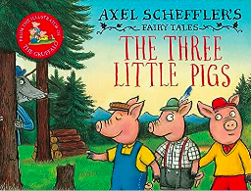 | 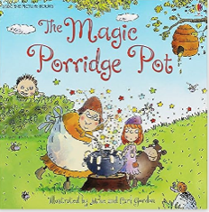 | 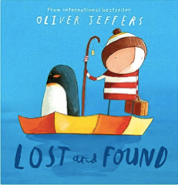 | 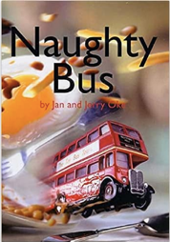 | 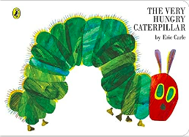 | 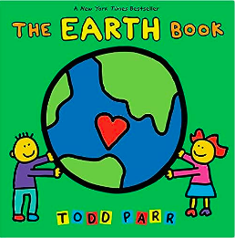
Year 1
Autumn 1 | Autumn 2 | Spring 1 | Spring 2 | Summer 1 | Summer 2
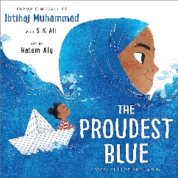  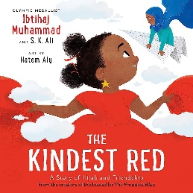 | 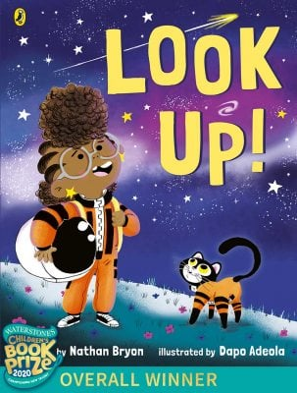 | 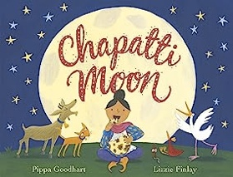  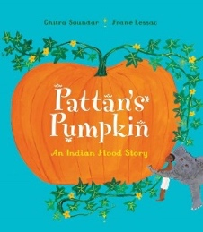 | 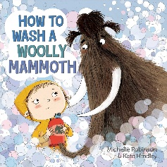 | 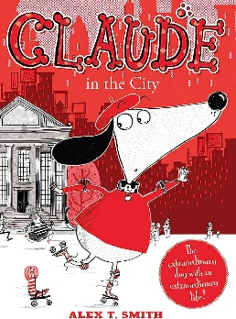 | 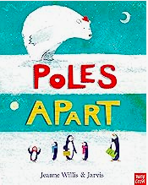  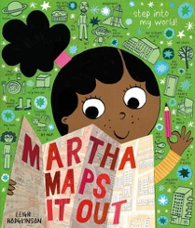
Writing to Entertain – Retelling | Writing to Inform – Invitation  Writing to Entertain – Shape poetry | Writing to Entertain – Short Story (Traditional Tales) | Writing to Entertain – Riddles  Writing to Inform - Instructions | Writing to Entertain – Short Story – Adventure | Writing to Entertain – Performance Poetry  Writing to Inform – Recount in Role (Diary)
Year 2
Autumn 1 | Autumn 2 | Spring 1 | Spring 2 | Summer 1 | Summer 2
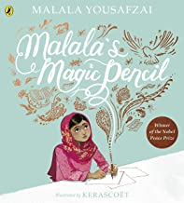 | 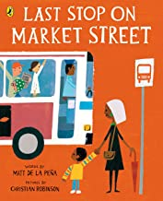 | 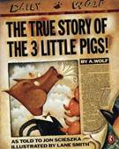  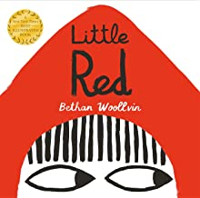 | 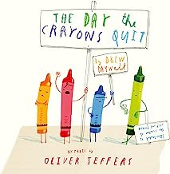 | 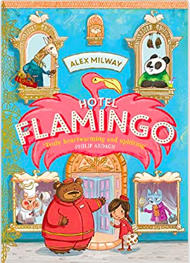 | 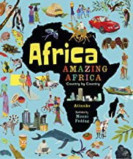  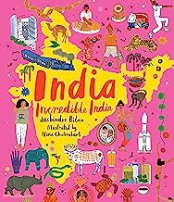
Writing to Entertain - Retelling | Writing to Entertain – Haiku poetry  Writing to Inform – Recount in role (Diary | Writing to Entertain – short story with a twist (traditional tales) | Writing to Entertain – Free Verse poetry  Writing to Persuade - Letter | Writing to Entertain – story sequel | Writing to Entertain – Free Verse Poetry  Writing to Persuade – advert
Year 3
Autumn 1 | Autumn 2 | Spring 1 | Spring 2 | Summer 1 | Summer 2
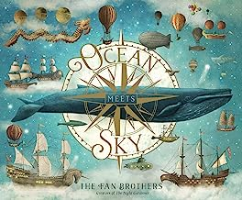 | 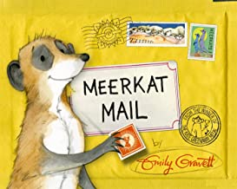 | 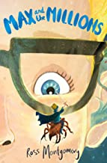 | 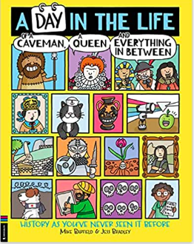 | 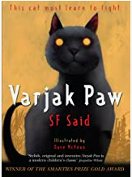 | 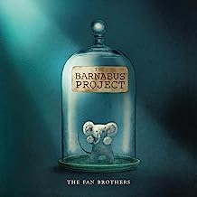
Writing to Entertain – short story | Writing to Entertain – Limerick poetry  Writing to Inform – Recount in role (Letter) | Writing to Entertain – story sequel | Writing to Entertain – Clerihew poetry  Writing to Inform – Information text | Writing to Entertain – missing chapter | Writing to Entertain – Free verse poetry  Writing to Persuade - advert
Year 4
Autumn 1 | Autumn 2 | Spring 1 | Spring 2 | Summer 1 | Summer 2
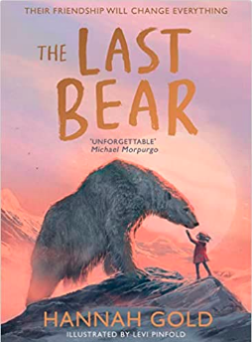 | 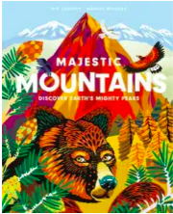  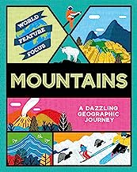 | 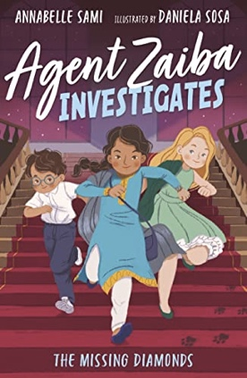 | 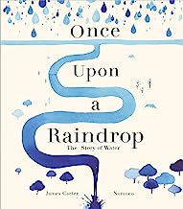 | 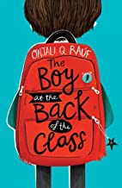 | 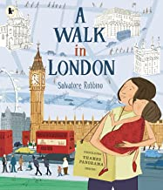  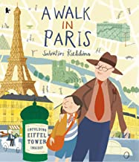
Writing to Entertain – short story | Writing to Entertain – Imagery poetry  Writing to Inform – Non-chronological report | Writing to Entertain – alternative ending | Writing to Entertain – Syllabic poetry  Writing to Inform – Explanation | Writing to Entertain – writing from a different point of view | Writing to Entertain – Performance poetry  Writing to Persuade – travel guide
Year 5
Autumn 1 | Autumn 2 | Spring 1 | Spring 2 | Summer 1 | Summer 2
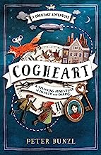 | 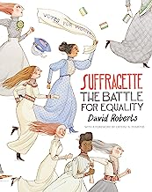 | 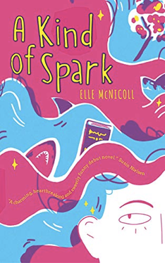 | 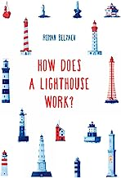 | 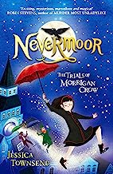 | 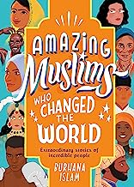
Writing to Entertain – missing chapter | Writing to Entertain – Kenning poetry  Writing to Persuade – speech | Writing to Entertain – alternative ending | Writing to Entertain – Free Verse poetry  Writing to Inform – Explanation | Writing to Entertain – short story | Writing to Entertain – Narrative poetry  Writing to Inform – Fact-file
Year 6
Autumn 1 | Autumn 2 | Spring 1 | Spring 2 | Summer 1 | Summer 2
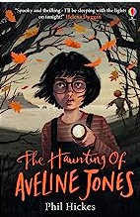 | 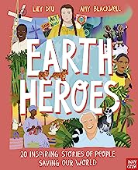  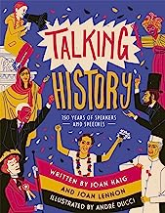 | 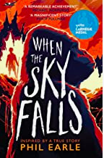 | 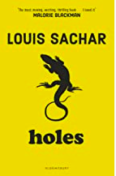 | 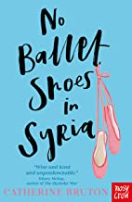 | 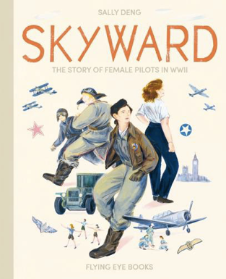
Writing to Entertain – missing chapter | Writing to Entertain – Narrative poetry  Writing to Persuade – speech | Writing to Entertain – short story | Writing to Entertain –Poetry on a theme  Writing to Inform – Biography | Writing to Entertain – writing from another point of view | Writing to Entertain – Classic poetry  Writing to Inform – Letter

